TC-DVA-004
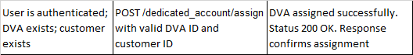
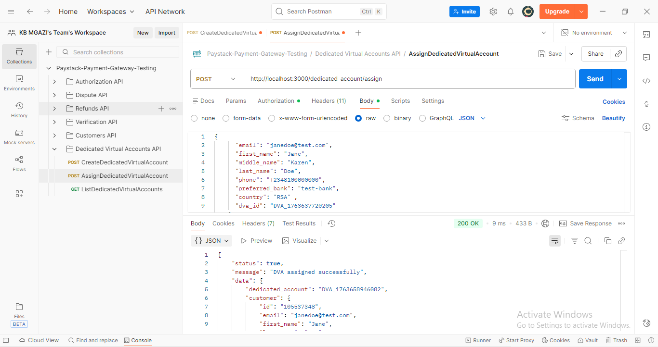
Request:
{
"email": "janedoe@test.com",
"first_name": "Jane",
"middle_name": "Karen",
"last_name": "Doe",
"phone": "+2348100000000",
"preferred_bank": "test-bank",
"country": "RSA" ,
"dva_id": "DVA_1763637720205"
}

Response:
{
"status": true,
"message": "DVA assigned successfully",
"data": {
"dedicated_account": "DVA_1763658946082",
"customer": {
"id": "105537348",
"email": "janedoe@test.com",
"first_name": "Jane",
"last_name": "Doe"
}
}
}

